Cost of living – short term funding bid (Cost of living support for Salford Students)

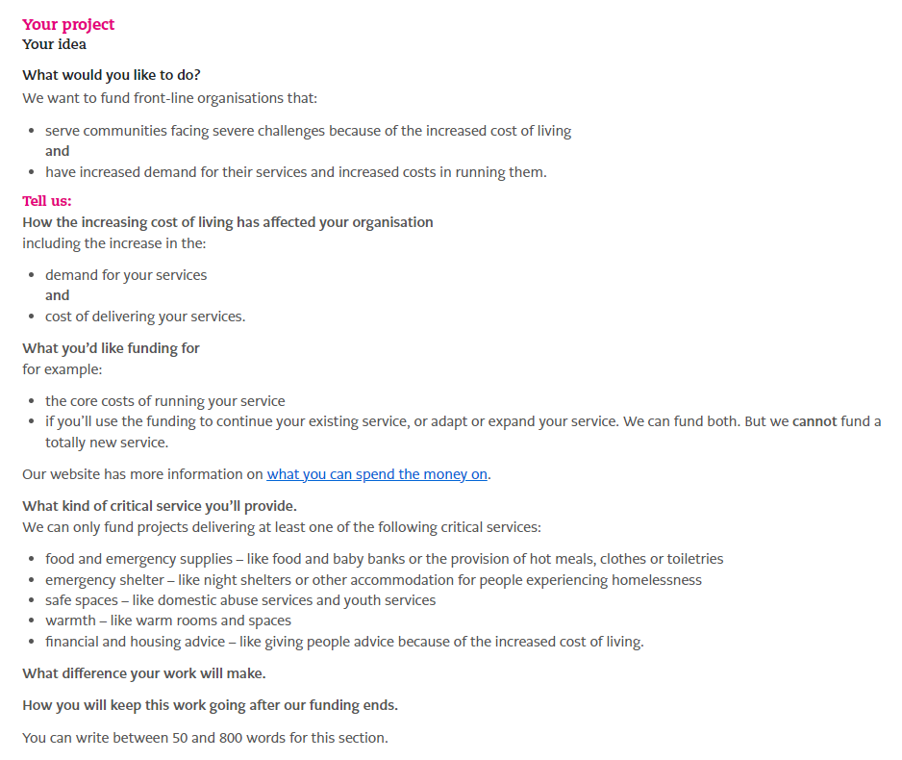

We would like to expand our wellbeing hub to develop a community space for our 28,000 student members. Students are one of the biggest communities impacted by the cost-of-living crisis with 92% of students saying their cost of living has increased and 46% of students reporting that their mental wellbeing and health has worsened due to the cost-of-living crisis. University of Salford Students’ Union has seen an increase in advice work by 52% in the last academic year meaning we supported even more students than ever. The cost-of-living crisis not only impacts students’ finances, but also stops students taking part in social activities, negatively impacts students learning experiences and causes housing concerns. This means that students are more likely to become lonely. 1 in 4 students already reports they are ‘often’ or ‘always’ lonely. The cost of the Advice and Wellbeing services at the Students’ Union has increased 104% compared to the previous financial year due to more student staff being employed to deliver more activity around reducing student loneliness and raising awareness of Students’ Union activity and support.

This funding will be used to expand the service offered from the Students’ Union Wellbeing Hub. The Wellbeing Hub already acts as a warm space for students who can engage in wellbeing activities and receive advice. We would like to use the funding to also offer students refreshments, hot meals and hygiene products such as toiletries and period products. This will prevent students from skipping meals as we are able to provide this for them as nearly 28% of students have said they skipped a meal to save money. This will mean students are more focussed and engaged on their studies. The space will also bring students together in a community and build friendships and connections as 47% of students have stopped or reduced socialising due to the cost-of-living crisis. Loneliness is the biggest barrier to learning for Salford Students and using enablers such as a hot food offer we aim to bring students together and improve their learning experience, increase their employability skills and support them through the cost of living crisis.

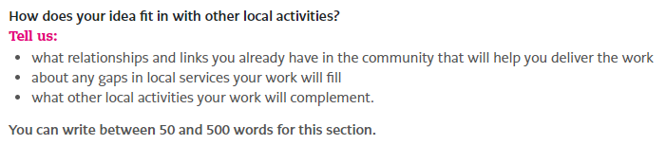

As an organisation we already have a kitchen which sells hot food, so availability of food is no issue. However, this funding will remove the cost barrier associated with the hot food offering and make it more accessible for more students. There are no services that currently offer student communities support on campus to provide free food and hygiene products, so this service is unique in delivery. This space will complement the work that the university does to support students with disability support, accommodation support and financial support. The University supports our cost-of-living interventions and actively promotes our warm spaces to students as well as our support services. There is a great partnership between the SU and the University to ensure students receive the correct advice and support they need.

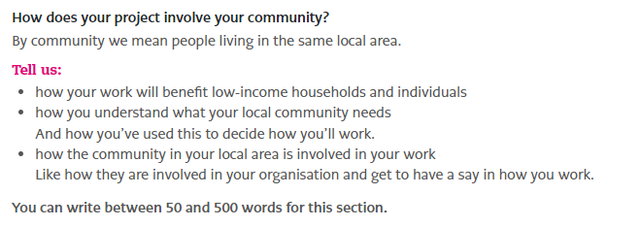

Students are some of the lowest income individuals within society with 1 in 4 regularly going without food or basic necessities and that 54% of students have reported their academic performance has decreased due to financial pressures and concerns. 32% of students have skipped a meal so that they are able to travel to university. By providing food and basic necessities such as hygiene products and toiletries, we can help to elevate the pressures that thousands of students are currently facing. By providing them with food and toiletries this will free up more student’s budget to spend on things such as travel to university.

A survey conducted by the Students’ Union found that 72% of students would like more support during the cost-of-living crisis. As a Students’ Union we are a membership-based organisation and we are led by our members, with 69% of our trustees also being charity beneficiaries. The work we commit to doing is lead by our elected officers who are the voice of the student body. We regularly engage with the student community to listen to their concerns, worries and feedback with an aim of improving their student experiences. The SU currently has over 600 student reps, 80 student staff and 12 officers who constantly share ideas and projects about how the Students’ Union can improve the lives of Salford students.

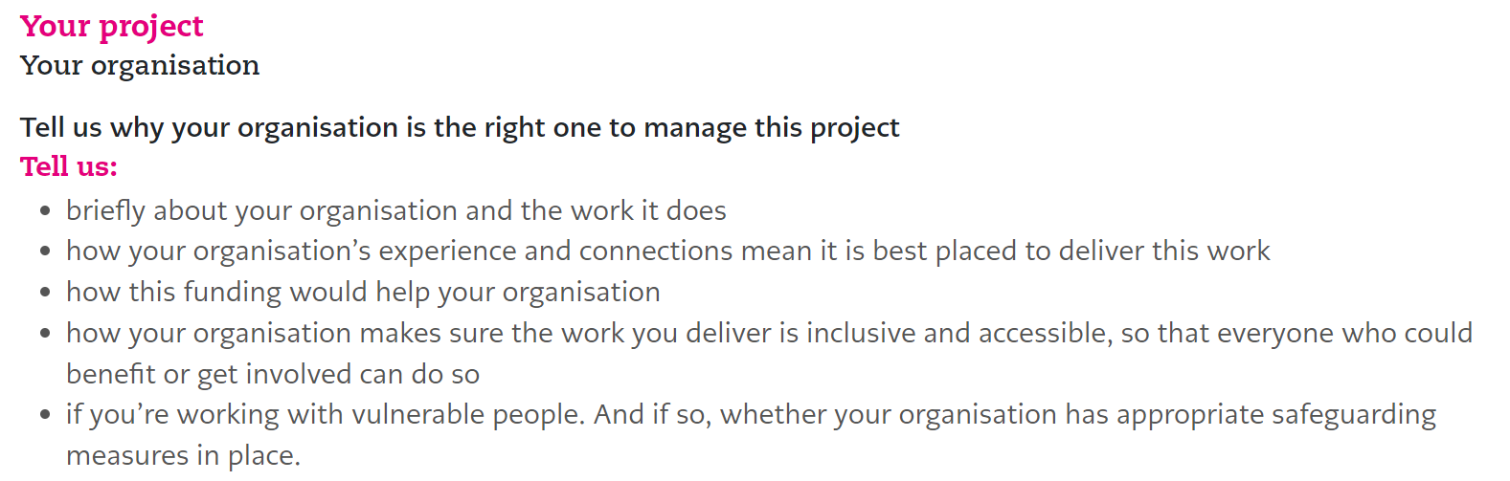

The University of Salford Students’ Union (USSU) is dedicated to eradicating student loneliness at Salford University, and all our efforts are aligned with this overarching mission. Our goal is to ensure that students thrive both personally and professionally, provide and environment where they can enhance their learning experiences as well as living happy and healthy lives.

Through a diverse range of initiatives, USSU aims to provide students with access to a wide range of activities and support services. We strive to create a sense of connection and community, enabling students to develop crucial social and employability skills. Our work is aimed towards motivating students to progress towards their goals and ambitions, empowering them to drive positive change and influence decisions within the university.

The Advice and Wellbeing department, responsible for overseeing this project, addresses a spectrum of student concerns, ranging from academic and housing issues to benefit support and overall well-being. By tackling challenges both within the university and externally, this department plays a pivotal role in supporting students on multiple fronts.

Every day, USSU collaborates with students through various channels, including societies, sports, advice casework, and volunteering opportunities. As the primary organisation connecting, engaging, and advocating for all of Salford University’s students, we are uniquely positioned to understand and address their needs. To ensure that our work is inclusive and accessible USSU engages with the liberation officers - elected representatives for specific communities, such as the Women’s Officer, Students with Disabilities Officer, BME Officer, and LGBTQ+ Officer. We constantly strive to improve our services and are committed to equitable opportunities, actively listening to and acting upon the voices of students facing additional challenges in accessing support.

This funding would enable us to deepen our existing support for students, alleviating the pressures they currently face. It would also allow us to expand the reach of our support, providing tangible assistance directly linked to the challenges posed by the cost-of-living crisis.